Asia Farmer-to-Farmer

The Farmer-to-Farmer (F2F) Program, funded globally by the United States Agency for International Development (USAID), provides volunteer technical assistance to farmers, agribusinesses, and education and extension providers in developing countries to promote sustainable improvements in the agricultural sector.

Since 1991, Winrock volunteers have completed over 5,000 assignments in 58 countries.
FAST FACTS

Donor: United States Agency for International Development (USAID)

Timeframe: Oct 2013 – Sept 2018

Funding Level: $8 million

Location: Bangladesh, Myanmar (Burma), Nepal

target beneficiaries: More than 150 host organizations, including public and private education institutions, NGOs, private agribusinesses, and farmers’ cooperatives/associations

contact information: Jennifer Snow, Program Director (jsnow@winrock.org)

The Asia F2F Program (Asia F2F) leverages the expertise of skilled volunteers to increase agricultural sector productivity and strengthen agricultural institutions, thus improving the service delivery of agriculture, education, and training (AET) institutions and increasing net incomes of enterprises and farmers (including youth).

Project Goal/Objectives
Asia F2F activities contribute to the following program outcomes:

- Strengthened AET institutions to provide agriculture professionals with improved technologies, curricula, and service-learning opportunities
- Increased capacity of youth-serving organizations to equip young adults with the skills to gain employment in the agriculture sector
- Increased productivity of farmers to improve production, service delivery, and market linkages

The program also contributes to the overarching objective of increasing Americans’ understanding of international development issues and programs, as well as international audiences’ understanding of the U.S. and U.S. development programs.

Activities
From October 2013 to September 2018, Winrock expects to mobilize 325 volunteers to strengthen 150 host organizations and work directly with 9,750 people. As a result, 3,300 farmers and enterprises will increase annual net incomes, and more than 70 public and private AET institutions will improve service delivery. F2F assistance includes:
- Support to AET institutions on organizational strengthening, pedagogical skills, curriculum development, and improved research techniques to develop agriculture professionals
- Training-of-trainers (TOT) support on youth development facilitation to strengthen the effectiveness of entrepreneurship training and increase employment of young adults
- Support to farmer’s groups on improved technologies, food safety, and organizational development to increase productivity and profitability

Results
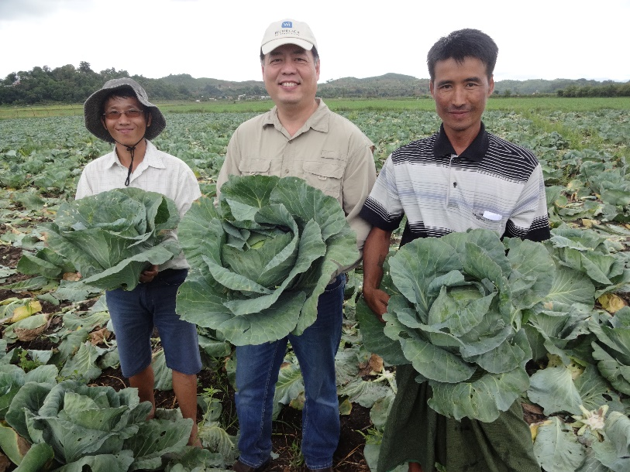
As of March 2018, 298 volunteers have directly assisted 19,080 individuals (33 percent women) in Bangladesh, Cambodia, Myanmar, Nepal, Turkmenistan, Vietnam, and Zimbabwe. Volunteers have supported 271 host organizations, including AET institutions, farmer organizations, and other NGOs to support agricultural and rural development.
“As a woman, I feel proud. I can contribute to my family income through improved cattle management, and help community people by providing information, which I learned from F2F training.”

-Papiya Khatan, Ashraf Foundation, Youth Group Member

As a result of F2F assistance, host organizations have demonstrated tangible improvements in agriculture sector service delivery. For example:
- AET hosts have introduced 103 new and improved products (e.g., curriculum and academic programs) and services (e.g., training services, laboratory services, and information dissemination).
- Youth-serving hosts have increased funding opportunities by $1.3 million to support youth agriculture entrepreneurs in advancing their businesses.
- In Myanmar, farmers and associations have applied improved technologies on over 13,000 hectares, thus improving productivity, and increasing sales by 6 percent.

With improved knowledge of avocado variety selection and evaluation from F2F trainings, the Myanmar Fruit, Flower, and Vegetable Producer and Exporter Association organized the first Myanmar Avocado Show, showcasing 191 Myanmar avocado varieties, better informing farmers’ production choices to reach new markets.

For more
info, visit:
www.winrock.org/volunteer

With support from volunteer assistance, the Plant Protection Department set up a fully functional Fungal Crop Diseases Diagnosis Laboratory, providing a valuable, new AET service to clients.

